Objectives:
To develop skills required in using computers in an office environment.
- Draw the following image using MS Word facilities
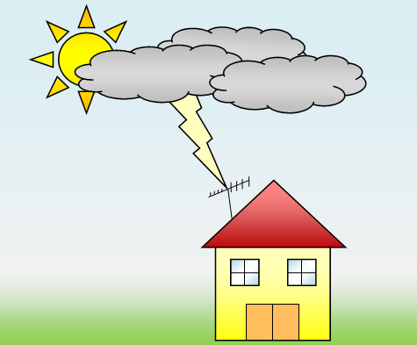

- You will use the drawing toolbar to create a detailed map that visually shows the route from your house to ATI using shapes, text boxes, and color. Save your document as Map to ATI.
Eg:

